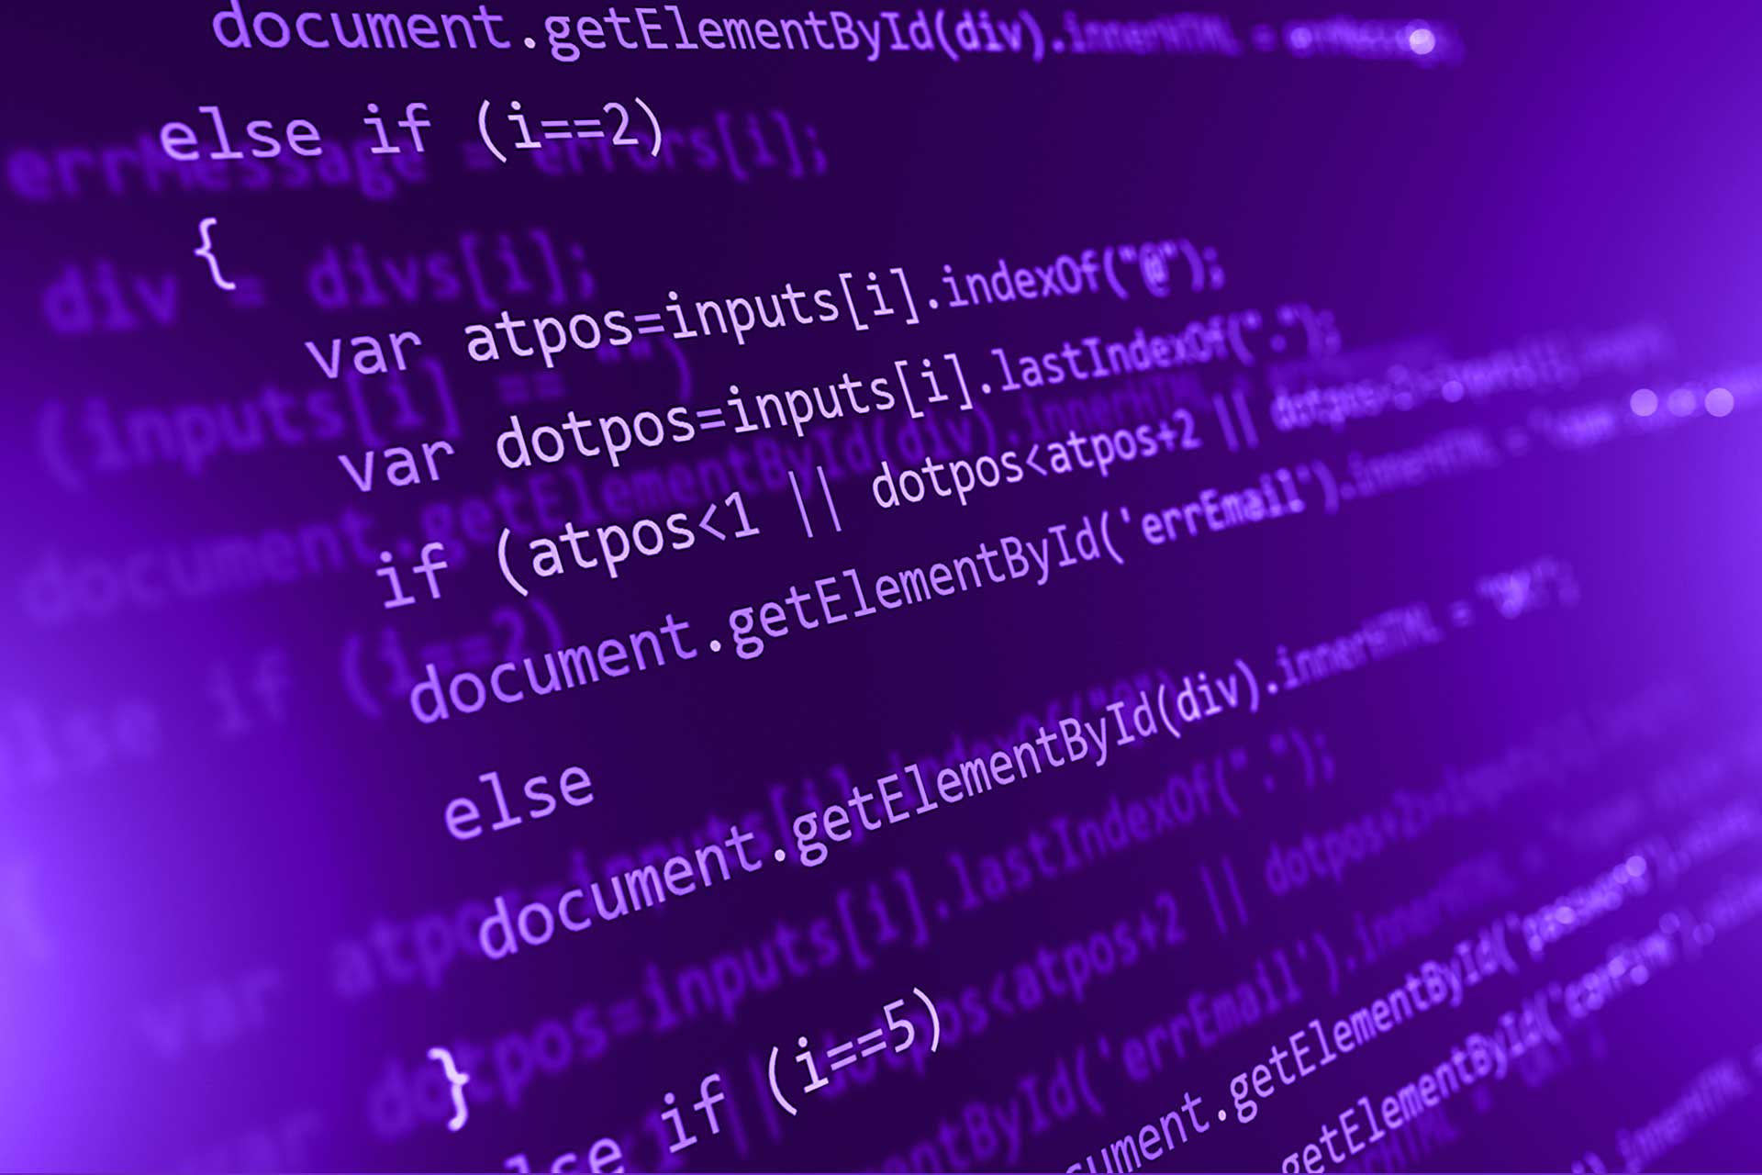

Understanding Code Comments: The Role of Linguistics in Software Documentation

Fatimaa khan

Ct-23024

## Question

Choose a recent research paper in your field with an interdisciplinary domain, such as English linguistics and software engineering.

Copy the original abstract. Then leave 5 lines, paraphrase your chosen research paper's abstract, and upload it.

## Abstract

The compilers are manufactured in such a way that they ignore most comments in software systems' source code. In addition to being a key source of system documentation, code comments are essential for both establishment and improvement. System comments or just quantitative assertions regarding the quality of the program are presently the only known techniques for evaluating software quality. In software development, comments are being used as a regular practice to enhance the clarity of code and to transmit the enthusiasm of programmers in a more conveyed manner. Whereas programmers seldom bother to keep their comments current. Comments are an important source of information about how the framework works. Various disciplines have concentrated on the content of the online client comments in different contexts, utilizing manual quantitative/subjective or (semi-)automatic methods. The wide variety and disciplinary partitions make it hard to get a handle on an outline of those views which have proactively been inspected. The huge number of daily comments inundating the newsroom can be amazing, particularly when a huge chunk is unfriendly or "contaminated" in content and tone. When dealing with complex documents such as source code, it can be hard to link the dots between the practical linguistic information contained within the code as well as the corresponding textual explanation found within the code, making it unsuitable for use in program analysis and mining assignments. Analysis of code comments on software improvement is examined in this research. Studies on code comments have been summarized in this paper, which covers four main areas: relevance of code comments, quality of code comment sources, code comment analysis, as well as a research approach for code comments and difficulties. It provides more comprehensive information for future research by analyzing effective methods for this study issue.

Interdisciplinary Domain: English Linguistics, Software Documentation, Software Engineering, Automatic Error Correction in Software Code.

## PARAPHRASING

A compiler is intended to disregard most comments in a source code, and pay no heed to the comments as it is inclined more towards the implementation of the actual code, itself. While on one hand, these comments often get paid no heed to on the compiler’s side, on the contrary, these comments prove to be extremely beneficial during system documentation. These comments often help improve the software and increase code readability. Currently, system comments are one of the only methods utilized to evaluate software quality. In the software development cycle, comments can help enhance code clarity and express the programmer’s logic better. However, comments are often overlooked by programmers who might not update comments every day.

Comments help explain what a piece of code does, and how the system is intended to run when that piece of code is compiled,

Different disciplines have focused on the content of online user comments in various contexts, using manual quantitative/qualitative or (semi-)automated techniques. The wide range of approaches and disciplinary divides make it difficult to form a clear overview of the perspectives that have already been studied. The overwhelming volume of daily comments can be challenging to manage, especially when a significant portion is negative or inappropriate in tone or content.

When working with source code’s, it can be challenging to connect the practical linguistic information within the code with it’s corresponding textual explanations, this makes it unsuitable for use in tasks like program analysis.

This research examined the analysis of code comments in relation to software development. It reviews studies on code comments, while also addressing four key areas, namely, 1. The impact of comments on your code, 2. The quality of code, 3. Code comment analysis, 4. Research methods and challenges in studying code comments.

The paper also aims to provide effective approaches to issues related to comments aswell.